
instructors only

Date : 2015/04/13
Course : Service-Oriented Architectures with Web Services
Course code : 192652150
Group : 09
Students[s] : Quan Wang, 1543881
Muhammad Arif Wicaksana, 1507850
Exercise series 2
Service orchestration with WS-BPEL:
Patient Treatment Flow
Table of contents
1. Business process specification 1
2. WSDL specification 3
3. Orchestration architecture 5
4. WS-BPEL process 7
5. Process deployment 10
6. Testing 11
7. Analysis of the WS-BPEL code 14
8. Multiple process instances 14

Introduction
In this assignment, we use WS-BPEL to develop Patient Treatment Flow. WS-BPEL is a standard technology that supports the combination of different web services working together as a business working flow.
The idea of Patient Treatment Flow is as the following: there is an imaginary hospital which provides patient treatment services. The service consists of the Radiology unit (for X-Ray and CT-scan examination), the Laboratory unit (to analyze blood and urine samples), and Transportation unit (to transport patient to the Radiology unit, and patient samples to Laboratory unit). There is also a centralized data storage, the Electronic Patient Record, which keeps all patient data and examination results. Patient treatments are conducted by Ward unit, which manage all needed activities related to the aforementioned units. It ranges from patient data entry, examination and transportation arrangement, and examination report management. Patient interaction with the hospital finishes when the Ward physician issues the discharge letter, which summarize the examinations conducted and also the analysis from the physician. The Patient Treatment Flow connects to all available web services and orchestrates all activities needed to accomplish requirements above.
From previous assignment, we already have 6 web services: lab service, lab callback service, patient service, radiology service, radiology callback service and transportation service. In order to orchestrate these web services together and to provide new service for Ward activities, we define and implement a new web service: ward service (Wardv2Artifact.wsdl). Two new operations related to Ward activity are defined in this WSDL file. Partner link types with the existing web services are also provided. This WSDL file itself becomes the reference for the business process BPEL file (Wardv2.bpel), which describe the Patient Treatment business process. Finally, we deployed this BPEL project in Apache ODE engine, which runs as a BPEL process engine to execute the business process.

Business process specification
The UML activity diagram is depicted in Figure 1. There are five entities involved: Ward, Electronic Patient Record unit, Laboratory unit, Radiology unit, and Transportation unit. The activity sequence can be illustrated as follows.
Firstly, Ward physician sends a patient admission data to the Electronic Patient Record. The data consists of patient personal data, all data needed for laboratory test, confirmation for transportation request, and all data needed for radiology examination. In the Electronic Patient Record, the patient personal data will be checked whether it has already kept in the patient record. If the record does not exist in the database, then a new record for the patient will be created.
Next, two parallel processes takes place: laboratory test and radiology test. In laboratory test process, the system sends a lab order first. Then, a request for sample transportation is generated. Later, when the sample analysis has been finished, the laboratory report will be generated. This report then will be stored in the Electronic Patient Record.
In Radiology examination process, firstly the system issues the request for examination. After that, an appointment request is issued, based on the patient’s expected date. If the patient declares transportation request, the system will arrange a request toward the Transportation unit. Later, after the examination finishes, the Radiology unit will send the report to the Ward. However, before the report is sent, the payment must be made first (this is the implication from the Radiology web service provided by other groups). Hence, the payment process cannot be made independent from the Radiology process. The report itself will be kept in the Electronic Patient Record.

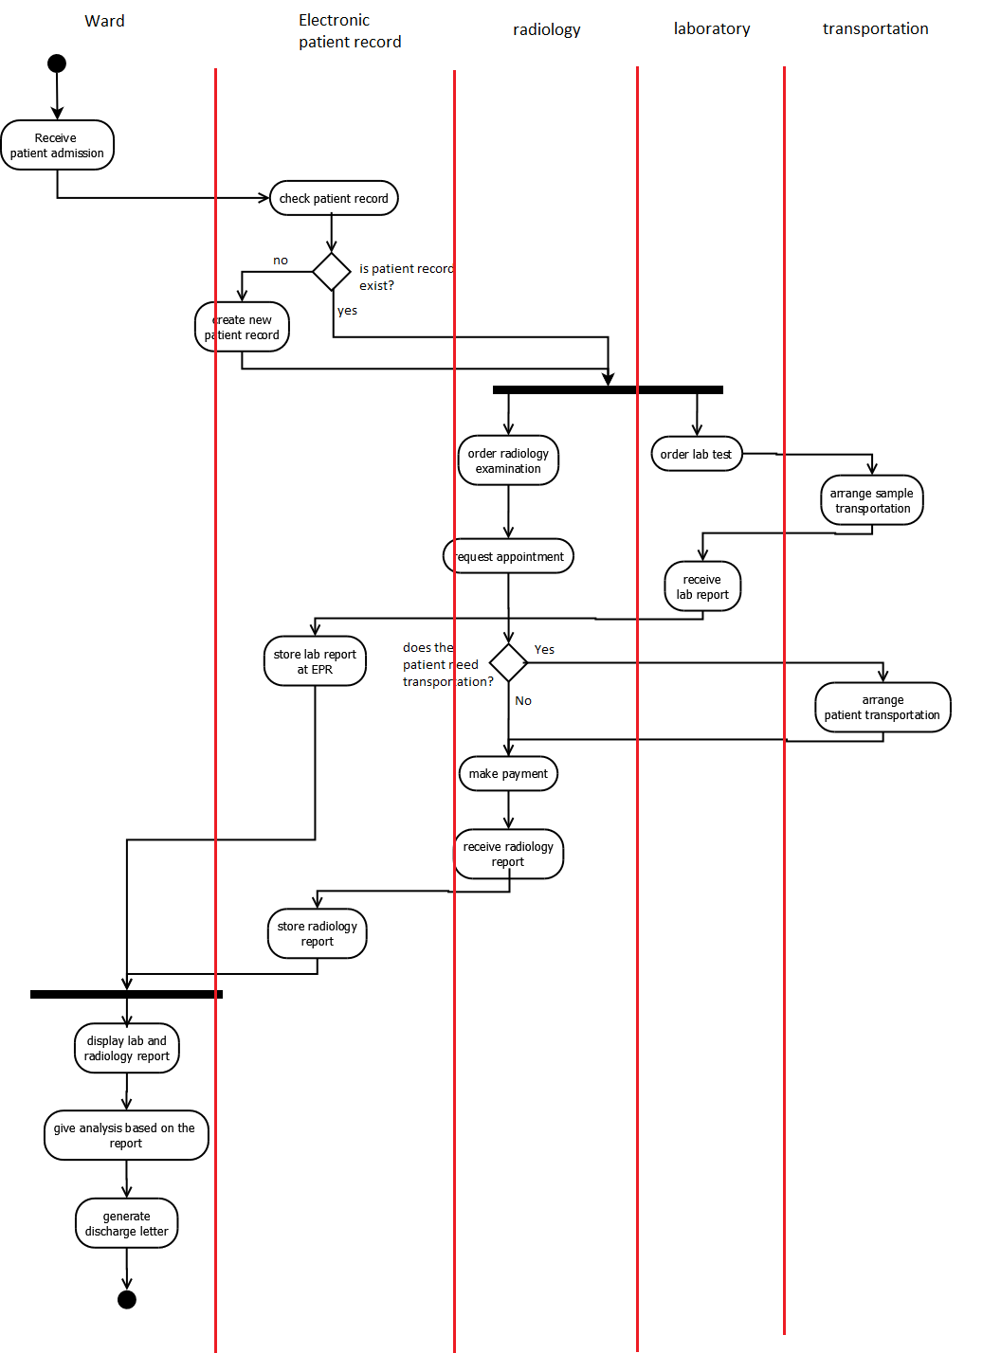
Figure 1 UML activity diagram

When both laboratory and radiology reports for a patient are available in the Electronic Patient Record, both data will be immediately sent to the Ward physician. Using this as the reference, the physician gives validation with some analysis, send it to the system, and then the system issues a discharge letter.
There are two additional activities here:
- Activity at the beginning of the business process, which allows the ward physician to enter patient data to the system. Upon receiving the information, the system will check the existence of the patient record. The output of this activity is the reports from laboratory and radiology examination.
- Activity at the end of the business process which allow the physician to view and validate both laboratory and radiology obtained from the first activity, and write an analysis which generate the discharge letter to conclude the business process.

WSDL specification
To implement two activities mentioned before, the Ward web service has two operations (Figure 2): Order and ValidateResult. Order is used to enter patient data to the system and provide the examination results in return, while ValidateResult is used by the ward physician to provide analysis which then issue a discharge letter, after reviewing the reports.
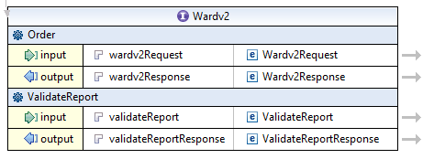
Figure 2 WSDL port type
For the first operation, the data structure for the incoming message is depicted in Figure 3. Patient ID (PatID), patient name (PatName), patient street address (PatStreet), patient ZIP code address (PatZipCode), patient city address (PatCity), and patient birth date (PatBirthday) are the necessary information needed to create a new patient record. Case ID (CasID), sample ID (SampID), sample material (SampMaterialType, either BLOOD or URINE), and laboratory parameters (LabPar) are the necessary input for all activities related to the Laboratory unit. Examination type (ExamType, either X-ray or CT-Scan), expected examination date (ExamDate), and the declaration of transportation need (NeedTransport; either Yes or No), are the variables for Radiology examination process. The rest variables are used by the Transportation service. The output message data structure of operation Order (Figure 4) consists of both reports from Radiology and Laboratory unit, which are to be reviewed by the Ward physician.
The second operation, ValidateResult, is performed after the Laboratory and Radiology reports are presented toward the ward physician. The input message, ValidateResult, contains patient ID (PatiID, for correlation purpose) and a String element, Validation, for the Physician analysis based on the reports retrieved. The output message, ValidateResultResponse, contains an element to send discharge letter generated by the system. The data structure for operation ValidateResult is depicted by Figure 5.
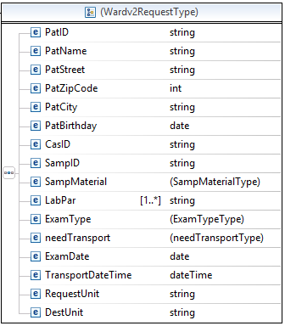
Figure 3 Data structure for patient admission activity
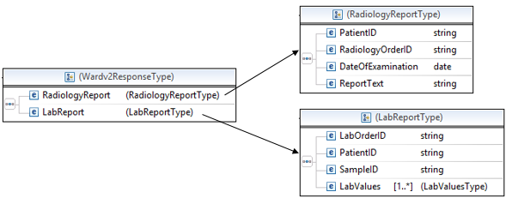
Figure 4 The output message data structure of operation Order

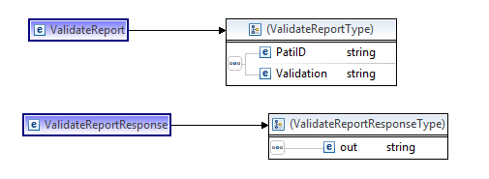
Figure 5 Data structure for input and output message of operation ValidateReport
To accommodate correlation between exchanged messages with the asynchronous web services, a property alias is also provided. There are two asynchronous operations in this project: laboratory callback (to receive the lab report), and radiology callback (to receive the radiology report). One common and unique elements to correlate them, with the patient input data is the Patient ID. The defined alias is depicted in Figure 4. It can be seen that all of those related variables are identified as PatID. This parameter will be used in the correlation sets configuration in the BPEL process file.
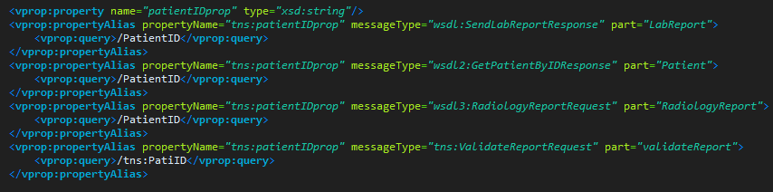
Figure 6 Property alias in the new WSDL file

Orchestration architecture
Partner link is used to describe the interaction between the business process and a specific partner. In order to connect the WS-BPEL with the available web services, the partner link types are defined in this new WSDL file.
From the existing web services and the newly defined one, we have identified and defined 5 partner links in total, which can be seen in Figure 7. Table 1 lists the defined name for each partner links, partner link types, and roles assigned as described in the Wardv2.bpel and Wardv2Artifacts.wsdl.
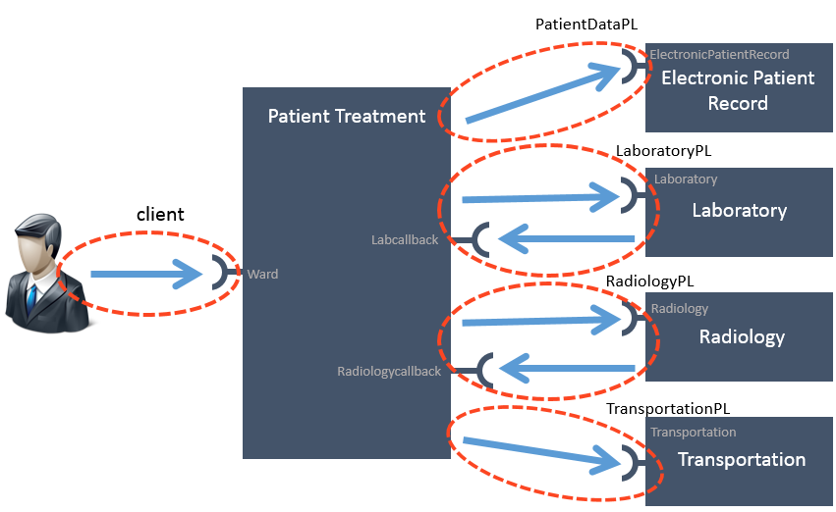
Figure 7 Overview of partner link definition for Patient Treatment system

Partner link client is used to define the relationship between the Patient Treatment business processes with the Ward physician The PatientDataPL describes the relationship with the electronic Patient Record web service. LaboratoryPL, RadiologyPL, and TransportationPL define the relationship with the respective web services.
Every partner link contains role assignments, which refer to the respective web service provider, from the BPEL process point of view. As mentioned in Table 1, for client, PatientDataPL, and TransportationPL partner links, there is only one role defined, that is the partnerRole. It is because there is only a single web service for each of them. The web services are the one provided by the service provider. On the other hand, LaboratoryPL and RadiologyPL partner links have two roles, with the addition of myRole. This is because aside from the web services provided by Radiology and Laboratory service provider, there is a callback web services at the Ward BPEL for each Radiology and Laboratory partner links, which is intended to perform asynchronous communication with the respective web services.
Table 1 Partner link, partner link type, and roles defined in the project
Partner link | Partner link type | Role
Client | Ward | myRole: WardProvider
LaboratoryPL | LaboratoryPLT | myRole: LaboratoryRequestor  partnerRole:LaboratoryProvider
TransportationPL | TransportationPLT | partnerRole: TransportationProvider
RadiologyPL | RadiologyPLT | myRole:RadiologyRequestor  partnerRole:RadiologyProvider
PatientDataPL | PatientDataPLT | partnerRole:PatientDataProvider

During the development of BPEL process, essentially all specifications of each partner web services must be known. It is important to know all operations provided by the partners, the port type, the data structure of input and output messages of the operations. Those are needed to define the element of the business process (such as variables, roles, correlations, etc.). In order to do this, we need to have the WSDL specification of our partner web services beforehand. If there is any specification about the partner web service which is not correct during development, the orchestration will be broken.

WS-BPEL process
The BPEL process designed in Eclipse BPEL designer is shown in Figure 9.
To implement the activity diagram (Figure 1) into a BPEL process, we use control type ‘sequence’ as the main container for the whole business process. In ‘sequence’, activities are executed one after another, based on their appearance order.
The first sequence activities (the upper sequence) are for patient record verification. First, the BPEL process receives input from operation Order. Here, the BPEL process gets all information needed to invoke operations from partner web services. In this activity, a new instance of BPEL process is also instantiated. To check patient status record in the Electronic Patient Record service, the operation GetPatientByID is invoked by supplying the entered patient ID. If the Electronic Patient Record service finds the mentioned patient ID, it will return the patient data. If the patient ID is not found, the Electronic Patient Record service will return a dummy patient data with value of patient ID as -1.
In the next activity, the ‘If’ activity, the returned patient data will be checked. If the supplied patient ID and patient name matches the returned patient data, then the patient is already registered. The process proceeds to the ‘flow’ activity. If the supplied patient ID or patient name supplied patient name does not match with the returned patient data, then the patient is regarded as not registered into the system (Figure 8). Here, the operation CreatePatientRecord from Electronic Patient Record service is invoked, and the new patient ID is returned.
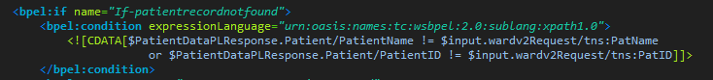
Figure 8 Code snippet of the ‘if’ conditional activity
Before the process enters the ‘flow’ activity, the operation GetPatientByID is invoked one more time. This is intended as a workaround to retrieve the valid patient ID, which will be used as a correlation with other messages later. Correlation cannot be applied for the input data from receiveinput activity, since there is no guarantee that the supplied patient ID (and data) is already in the record.
After verifying the patient data record, the next step is the ‘flow’ action type. ‘Flow’ action is used to execute several activities in parallel. Here, there are two sequence activities which are executed concurrently. These are ‘sequence-laboratory’, the laboratory activities sequence, and ‘sequence-radiology’, the radiology activities sequence.
‘sequence-laboratory’ starts with invoking OrderSampleTransport from Transportation service. It provides the information of patient ID, sample ID, and the requesting unit. The next step is ordering a laboratory test, by invoking OrderLabTest from Laboratory service. The laboratory report is sent later, through using the callback web service at the BPEL process. The retrieval of laboratory report is done by activity ‘Receive-labReport’. Since this is an asynchronous communication, the incoming message containing the lab report needs to be correlated with the appropriate BPEL instance.

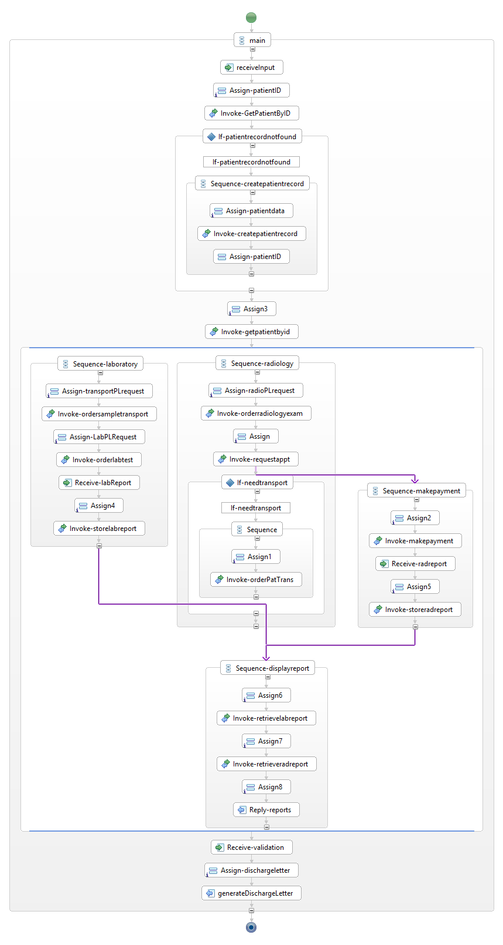
Figure 9 BPEL Process designed in Eclipse BPEL Designer
The correlation is done through the parameter of patient ID from the lab report and the patient ID retrieved from the second invocation of GetPatientByID. After the lab report is received, it is then stored at the Electronic Patient Record service through invocation of operation StoreLabReport.
The next activity sequence, ‘sequence-radiology’, starts with invoking OrderRadiologyExam to retrieve the Radiology order ID. Then, operation RequestAppointment is invoked to reserve an examination for a certain date. After this, a patient transportation is arranged if the patient states so in the patient input data, by invoking OrderPatientTransport from Transportation service. In addition, another activity sequence is also started independently right after invoking RequestAppointment (by using a link), which named after ‘sequence-makepayment’. Here, patient should make the payment first, before the radiology report sent. In this business process, the patient is assumed to immediately pay the service beforehand, hence the operation MakePayment is invoked automatically. After payment is made, the radiology report is sent later through the callback web service implemented in the BPEL engine. This report is retrieved through the activity ‘receive-radreport’, and then stored at the Electronic Patient Record service by invoking operation StoreRadReport.
After both sequence-laboratory and sequence-makepayment finishes, another activity sequence is started, that is sequence-displayreport. This behavior is implemented by using join condition ‘AND’.
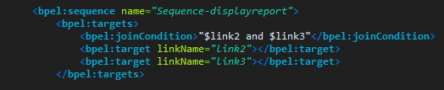
Figure 10 Code snippet of conditional join condition ‘AND’, which requires both previous activities to be fulfilled first before starting the subsequent activity (sequence-displayreport)
The sequence-displayreport invokes RetrieveLabReport and RetrieveRadReport to get the reports, to be sent back to the Ward physician as the output message of operation Order.
The next step is waiting for the analysis input from the physician regarding the report results. This is performed by activity ‘Receive-validation’. It also marks the start of the second operation of Ward web service, the ValidateReport. After receiving input from the Physician, the BPEL process arranges the discharge letter. This is done by using XPath’s concat function (Figure 11), to combine variables from previous activities into a summary as the content of the discharge letter, which is then returned to the physician as the output message of operation ValidateReport.
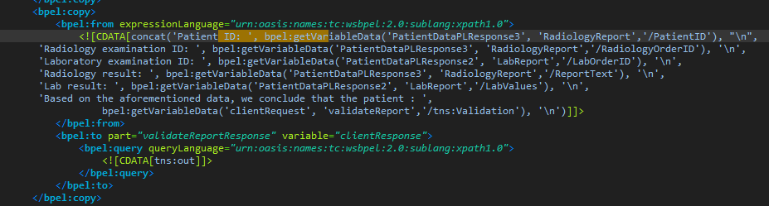
Figure 11 Code snippet of XPath’s concat function to generate discharge letter
From the previous description, it is clear that the Ward physician is protected from the internal process of the Patient Treatment Flow. The only two interactions between the physician and the Ward process is when the physician enters the patient data and then later retrieve the reports, and when the physician needs to enter his/her analysis regarding the report results to generate the discharge letter. This will become clear in section 6.

Process deployment
Our deployment strategy uses two different machine: a virtual machine (192.168.216.128) which runs all web services from assignment 1, and the host machine (192.168.216.1) which runs the Apache ODE engine. The complete diagram of our deployment system is presented in Figure 12.
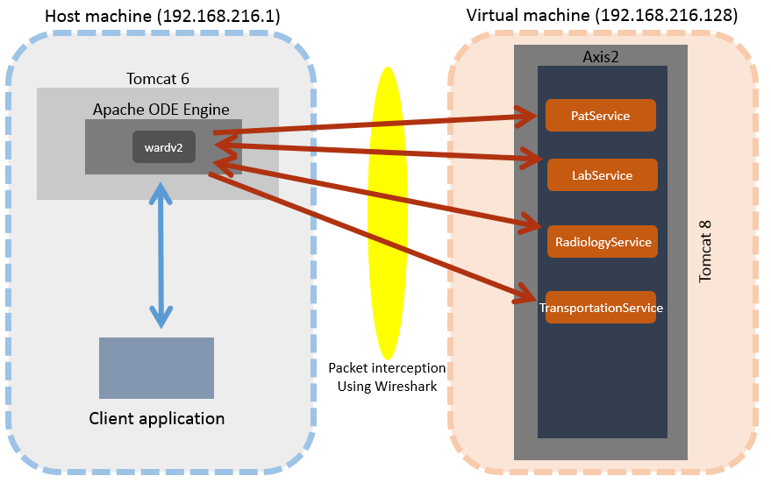
Figure 12 Deployment diagram
To analyze the SOAP messages, we found that the use of Wireshark is more flexible and easier to use than the TCP/IP Monitor provided by Eclipse. It does not require us to specify a certain port to be monitored, and it allows us to read the whole packet, not only the SOAP message. However, Wireshark cannot be used to listen on localhost interface in Windows, hence the need to use the virtual machine to simulate different server. We use this tool for our testing later.
The web services PatService, LabService, RadiologyService, and Transportation Service are deployed on Axis2 by uploading the .aar file via Axis2 web interface. The Axis2 itself runs on top of Tomcat 8 inside the virtual machine.
The WS-BPEL process itself (Wardv2) is deployed on Apache ODE Engine, which is deployed on Tomcat 6 in the host machine. The callback web services are also run by ODE Engine. However, we do not need to deploy the .aar file. We only need to put the WSDL files in the BPEL project directory, and define the necessary configuration in the ward’s WSDL file and BPEL process file, then the ODE Engine will automatically run the callback service.
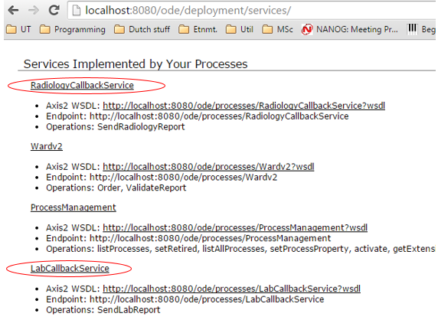
Figure 13 Callback services are implemented by ODE Engine
Since there is no requirement to deploy the WS-BPEL process outside Eclipse, we use the facility provided by Eclipse to do that. The purpose of this is to make us more convenient during debugging and testing the code, since we do not need to open too many applications.
After we finish creating the WSDL and BPEL files, we create the deploy.xml. This is an XML file which is used to describe the necessary information regarding the partner links, its respective associated ports, and the binding used. These information is for both the inbound interface (web services run by the ODE engine), and the outbound interface (web service run by partners). This file is used by the Apache ODE engine to deploy the WS-BPEL process.

Testing
To test the WS-BPEL process, we develop a console-based Java client application. This application uses stub files generated using Axis2’s tool wsdl2java.bat, by providing the URI of the Wardv2 WSDL. We include the client application (ward-client) together with this report.
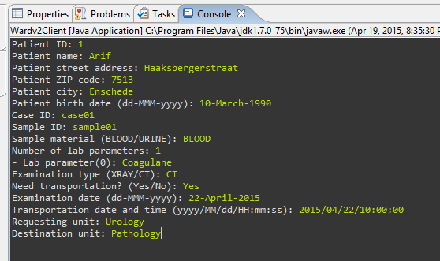
Figure 14 Patient data input
The test scenario is as the following (Figure 12 as the reference): Suppose there is a new patient arrives. Then, the ward physician enters the patient data using the client application, as shown in Figure 14. The application then contacts the BPEL process server. The BPEL server will communicate with its partners based on the business process shown in Figure 9.
The exchanging packets containing SOAP messages between ODE engine and the web service partners captured by Wireshark is shown in Figure 15. The packet sequence is matched with the business process in Figure 9.
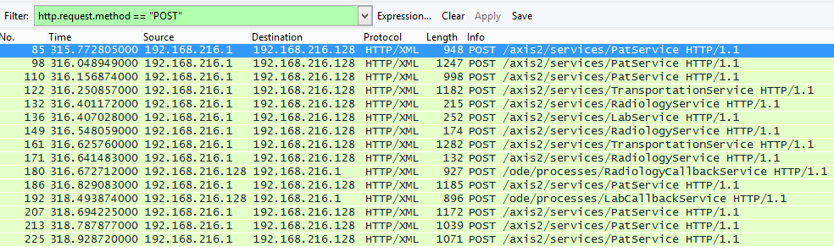
Figure 15 HTTP packets containing SOAP messages exchanged between ODE Engine and the web service partners
The last packet, packet number 225, contains the output message of the operation Order from Wardv2 process, which returns the laboratory and radiology reports to the physician. The content of that SOAP message is depicted in Figure 16.
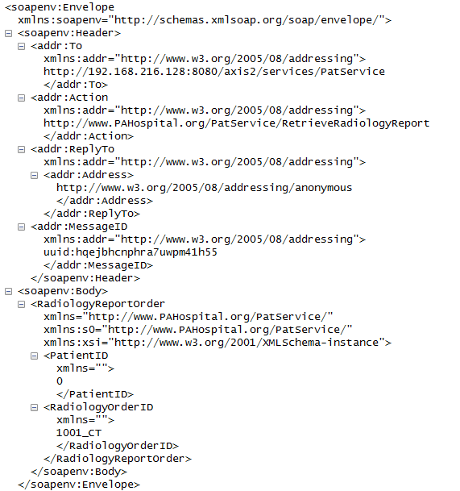
Figure 16 output SOAP message from operation Order
The reports itself is displayed to the Physician as shown in Figure 17. Here, we see that the Patient ID is 0, even though the Physician entered the ID as 1 (Figure 14). This is because the Electronic Patient Record service does not have patient data with ID 1. Hence, the system creates a new patient record, with patient ID 0.
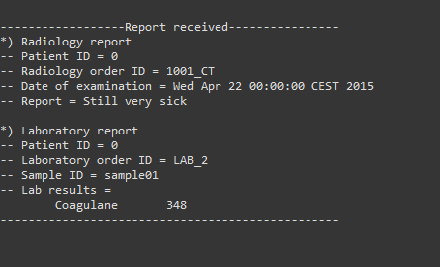
Figure 17 Radiology and laboratory reports
The next step is for the Physician to analyze the report. Here, in Figure 18, the physician provides his professional opinion for the respective patient. This activity is in fact the invocation of operation ValidateReport from Wardv2 process.
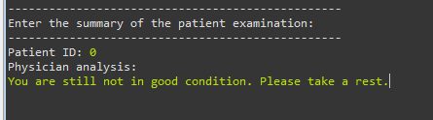
Figure 18 The physician provides the analysis for the respective patient
Having sent the analysis to the ODE engine, the system will process the discharge letter, and send it back to the physician (Figure 19). Somehow, the text formatting is not working properly, but we hope that the output is clear enough about our intention.
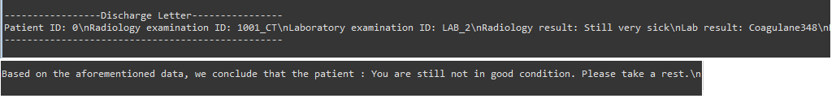
Figure 19 The generated discharge letter
Note that the discharge letter produced contains some information from the previous messages, such as radiology exam ID, lab ID, radiology result, lab parameter and value, and also the physician analysis. All of these data is combined using concat method (Figure 11). This is intended to prove that our solution works properly.
The complete screenshot of the whole testing above can be seen in Appendix 1. We also include the packet capture file of the SOAP messages as the evidence.

Analysis of the WS-BPEL code
As can be seen from Figure 9, our solution is mainly constructed from sequence control, which execute activities subsequently. This is because sequence control is simple to debug. When we need to perform parallel activities, such as radiology and laboratory activities concurrently, we use flow control. Inside our flow control, we put several activity sequences to group activities with the same common goals (e.g., order radiology examination, order lab test, returning the lab report to physician, and make payment).
In terms of flow logic, there are two kinds of flow logic used, the first one is the ‘If’ control, and the second one is the link control.
The ‘If’ control is used to define possible activities based on the conditional situation. In our case, we need this behavior during determining whether the patient personal record exists in the Electronic Patient Record service (Figure 8), and during determining whether the patient needs the transportation for radiology examination (Figure 20).
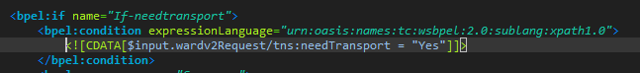
Figure 20 Code snippet of ‘If’ flow control to determine the need of patient transport
The second one, the link control, is used to define the order of activity execution inside a flow. As we know it, in flow control, all activities are executed in parallel. We can modify this behavior by providing a link between two activities, so that the target activity is executed after the source activity is finished.
In our case, we need the link control in two situations. First, when we need to start payment activity independently from radiology sequence right after we receive the radiology ID (which is received after invoking operation RequestAppointment), and secondly, to send the reports only after when the laboratory sequence and payment sequence finish (Figure 10). For the latter situation, we also need to define the join condition, which is an ‘AND’ operator, so that both source activities to be finished first before the target activity is executed.
The same result for Patient Treatment Flow can be accomplished using different approach. Our solution above can be modified to use a flow control as the main activity, instead of using a main sequence. Then, all closely related activities are grouped, and connected to each other using links. In this way, our solution will contain group ‘validate patient record’, ‘radiology sequence’, ‘laboratory sequence’, ‘submit report to physician’, and ‘generate discharge letter’ (for the last three activities from our solution).
Here, there should be a link from ‘validate patient record’ to both ‘radiology sequence’ and ‘laboratory sequence’, and from both of them there are links toward the ‘submit report to physician’, and then a link from it to the final activity group; ‘generate discharge letter’.

Multiple process instances
In our solution, every time the operation Order is invoked, a new process instance is created. This is before in activity ‘receiveInput’ we define this behavior (by providing createInstance="yes" in that activity description) Instantiation is useful, because it allows us to serve multiple patients simultaneously. Without instantiation, there will be a long queue of patients to use the Patient Treatment flow, since only one patient can be served at a time.
To monitor the instances of a WS-BPEL process, we can use Apache ODE engine feature. Typically, we can access this at the following URL:
http://<ODE_engine_address>/ode/instance.html.
Figure 21 provides an example when an instance is created in the ODE engine. Here, the status is Active. It means that the instance is currently still in progress. When the instance is finished, the status will be changed into ‘completed’. In this way, we can keep track of progress of all instances.
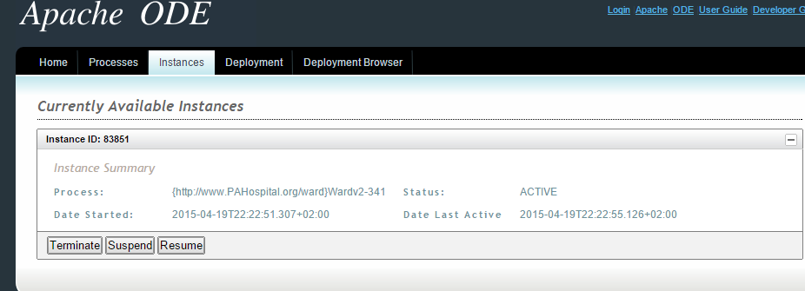
Figure 21 Example of an instance status monitoring
When there are many instances running at a time, there are also many similar messages passing around. To match up the message with the proper instance, we need to define Correlations.
In our case, the Correlation is needed for the inbound messages of asynchronous communication (message sent to callback web services) and the input message of operation ValidateReport. All of them are correlated with the reply message from the second invocation of operation GetPatientByID (as mentioned before in section 4). To correlate all of those message, we need a common data in those message, yet unique. Here, we select patient ID as our correlation base. To add correlation to a process, first we need to create message properties and property aliases (Figure 6) in the WSDL file. Then, we create a Correlation Set in our BPEL file (Figure 22).
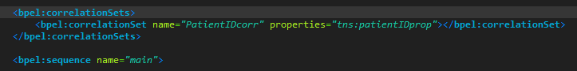
Figure 22 Correlation Set defined in Wardv2.bpel
When an instance of is created, at some point it will reach the activity which starts the initiation of the correlation. The correlation is defined for a certain variable. For the later messages, this selected variable (as described in property alias in WSDL file) is used to be compared with the variable which initiate the correlation. If matches, then the messages belong to the same instance. In this way, we ensure that the requests are forwarded to the proper flow instances.
To monitor the correlation process, we can keep track of the variable which is used as the correlation identifier. In our case, the variable is the patient ID. Back in our testing from section 6, the patient ID for that instance is 0. From the packet dump file, we see that the incoming message for callback services are also intended for patient ID 0 (Figure 23 and Figure 24).
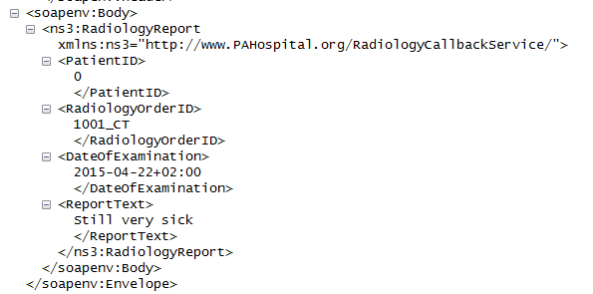
Figure 23 Radiology report retrieved at radiology callback service, intended for patient ID 0
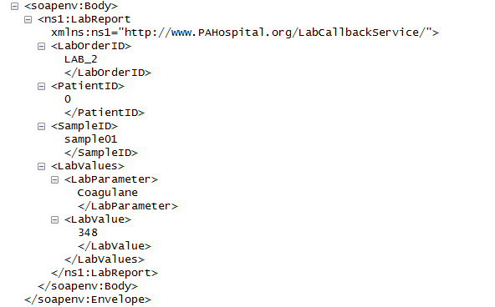
Figure 24 Laboratory report retrieved at lab callback service, intended for patient ID 0
Subsequently, the physician should also input the appropriate patient ID (Figure 18), so that the process can relate the physician input analysis with the previous messages for the same instance. As result, the discharge letter can be generated which contains information retrieved from previous messages of that instance.
Appendix
- The complete screenshot of the testing
The output of discharge letter is displayed in a single line. We edit the picture so that it contains all the content of discharge letter for readability purpose.
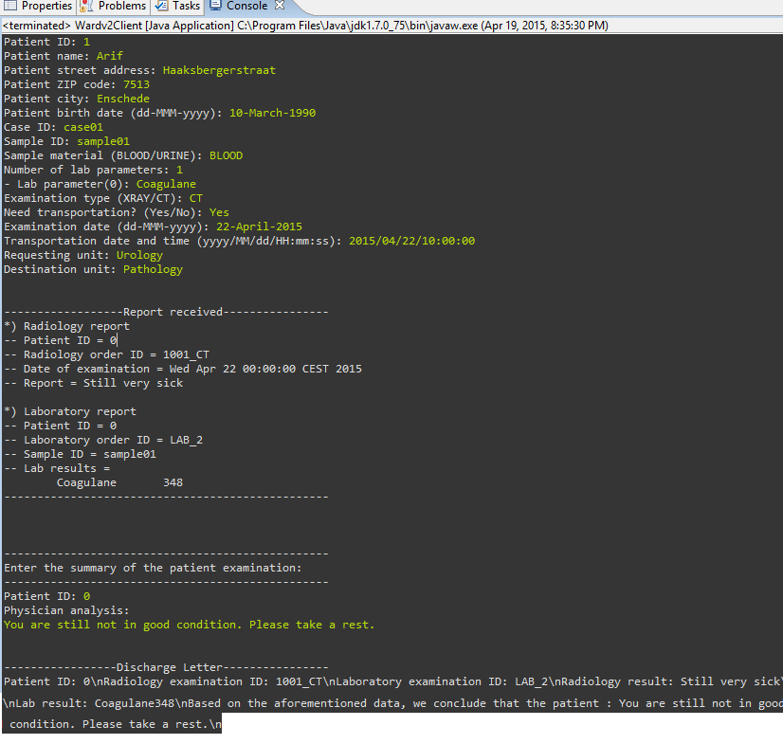

Wireshark is a popular open-source packet analyzer

